Curriculum Vitae

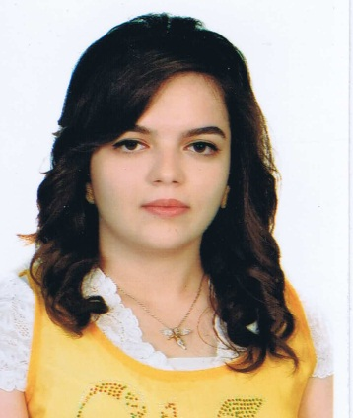

**Marwa Abdullah Muhammed**

*Computer engineering*

*(e-mail) marwaabdullah1995@gmail.com*

*(Mobile) +964 7715886935*

**P**ERSONAL **I**NFORMATION :

* Nationality German-Iraqi
* Birth Date & Place 19.11.1995 kirkuk/iraq
* Marital Status  Single

**L**anguages :

Turkish (native), English (excellent fluency),Arabic(excellent fluency),Kurdish(moderate fluency),German(moderate fluency)

**E**DUCATION and **A**CADEMIC **D**EGREES

* INTERNATİONAL ISHIK UNIVERSITY ERBIL , *2018 / JUN – present*. COMPUTER ENGINEERING

**W**ORKING **E**XPERIENCE

jun 2017

Transport logistik **&**Money manager |HS Arbeitnehmerüberlassung &Logistik e.K.|

Nürnberg,germany

**C**ONFERENCES and **W**ORKSHOPS

* **“***Definition Of Horyat In Iraqi Turkmen Folk Poetry And Its Etymological Analysis*”, 5. International Visible Conference on Foreign Language Teaching and Applied Linguistics in Ishik Univ. And Salahaddin Univ. April 13-14, 2014 Erbil-IRAQ
* Culture and Science Festival was held **at** ishik university in Erbil,Iraq Awarded on:April 12,2017
* English Lnguage Preparatory school academic year 2013/2014

**R**ESEARCH **I**NTERESTS and **E**XPERIENCES

* Photoshop
* Language
* Business
* marketing

**C**OMPUTATIONAL **E**XPERIENCE

* Microsoft office: (Word, Excel, Power Point), Java, HTML, CSS, PHP,Internet communication.

**S**EMINARS, and **C**ERTIFICATES

* Certificate of Appreciation, “Languge and Culture Festival”, Ishik Univ, 2016, Erbil/ IRAQ
* Certificate of Participation, (NICE 2018) National Innovation Contest in Engineering, 2018, Erbil / IRAQ
* English Certificate, (Preparatory course) Ishik University , 2013/2014, Erbil / IRAQ